- The department organized inaugural and orientation programme for the new entries into the academic year-2018-19. The elite heads of management hosted the event and assured the students as well as the parents of the bright careers at the campus. They expressed their gratitude to the parents for trusting in the efforts of the management and admitting their wards in a very considerable number.
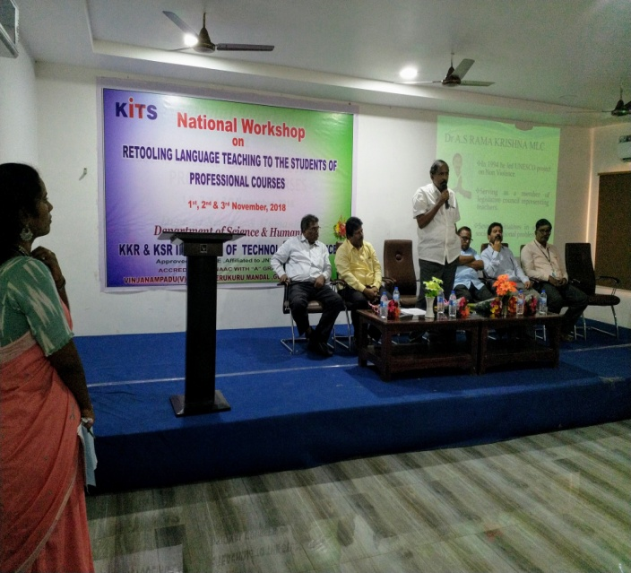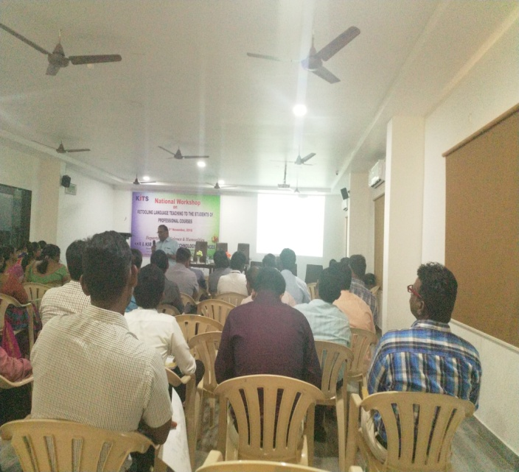

The department of English organized a national workshop on “Retooling Language Teaching To The Students Of Professional Courses” on 1st ,2nd and 3rd of Nov. 18 with presentations on
- Attitude pertinent to teachers 0f professional courses
- Pedagogy related to language teaching
- Communication from corporate view
- The art of presentation of content
- Evaluation of syllabus
Dr G.Chenna Reddy,. Dr P.Yamini, Sk. Shabreen Sulthana prof. P Gopichand & P.Naga Suseela are the resource persons
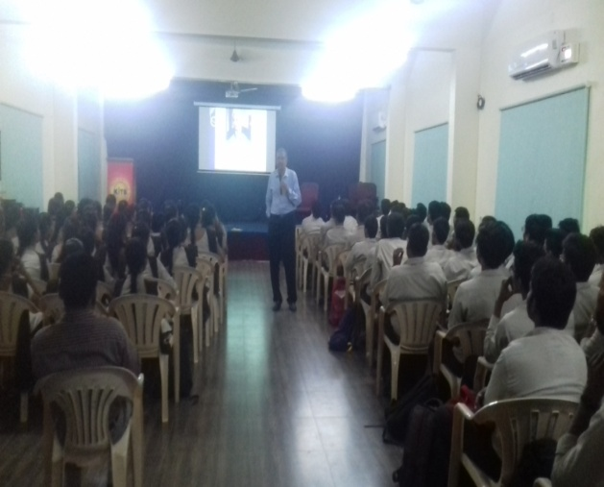
An orientation program for the first B.Tech students was held for two days ie..,20th & 21st Nov,18 Prof Sarma of Ramakrishna math, Hyd gave a presentation on general English for daily routine , setting goals and efforts to achieve goals.

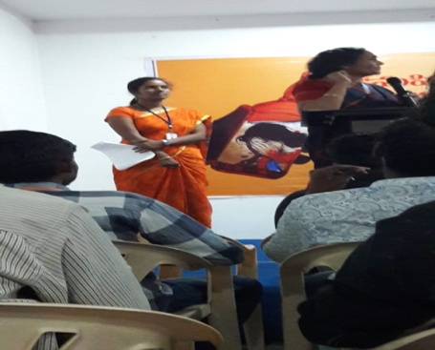
- Dr T.D. Vimala, a noted Psychologist gave a lecture on Mentoring and Counseling. She explained how every teacher could play the noble role as a good mentor and counselor to a student in shaping him up as a useful citizen.

Smt. Rajani, Justice, AP High Court gave a lecture on suicide tendencies among the youth and atrocities against the women. She told that alcohol could be the prime motive behind many evils in society. So the youngsters should never indulge in consumption for fancy and friends.

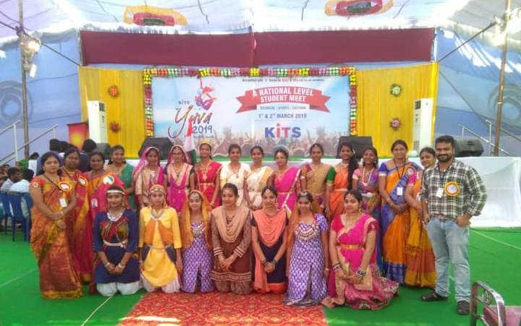
The 1st year students performed a dance recital signifying national integrity at KITS YUVA – 2019. The team won 1st prize for its beautiful performance. A few more teams performed some cultural events which received big applaud from guests.
The 1st year girl students took an enthusiastic part in the march past held at the inauguration of sports meet which caught the attention of all the participants.
The KHO-KHO team girls stood as runners in the meet.

